1. Introduction
   1. Overview

CO2 emissions in India rebounded strongly in 2021 ro rise 80 Mt above 2019 levels, led by growth in coal use for electricity generation. Coal fired generation reached an all time high in India, jumping in 13 % above the level in 2020 when coal generation had declined. Carbon dioxide is the primary greenhouse gas emitted through human activities. In 2021, co2 accounted for 79% of all U>S> greenhouse gas emissions from human activities.

1.2 Purpose

Co2 emissions in 2022 provides a complete picture of energy related greenhouse gas emissions in 2022. The report finds that global growth in emissions was not as high as some had originally feared amid the disruptions caused by the global energy crisis.

1. Problem Definition and Design Thinking

## Empathy map

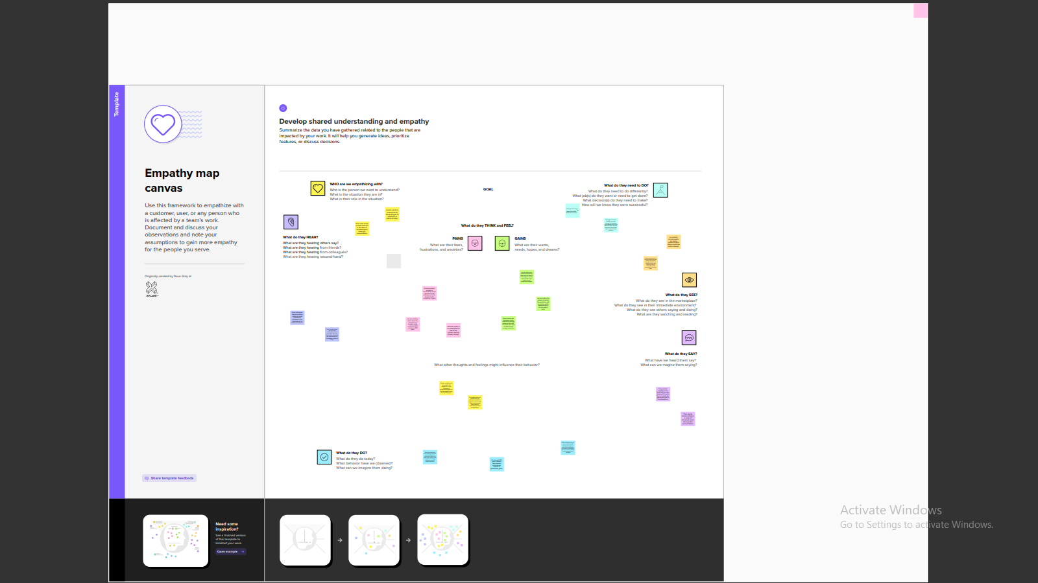

## Ideation and Brainstorming map

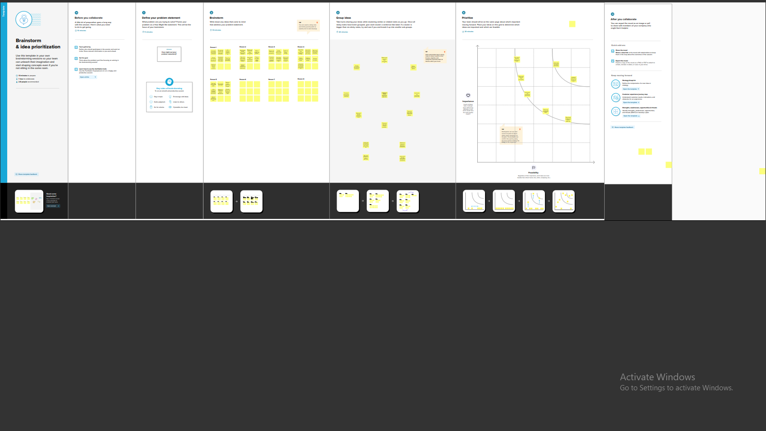

# Results

* 1. Data Model

|  |  |  |
| --- | --- | --- |
|  |  |  |
|  |  |  |
|  |  |  |

# Activity and Screenshots

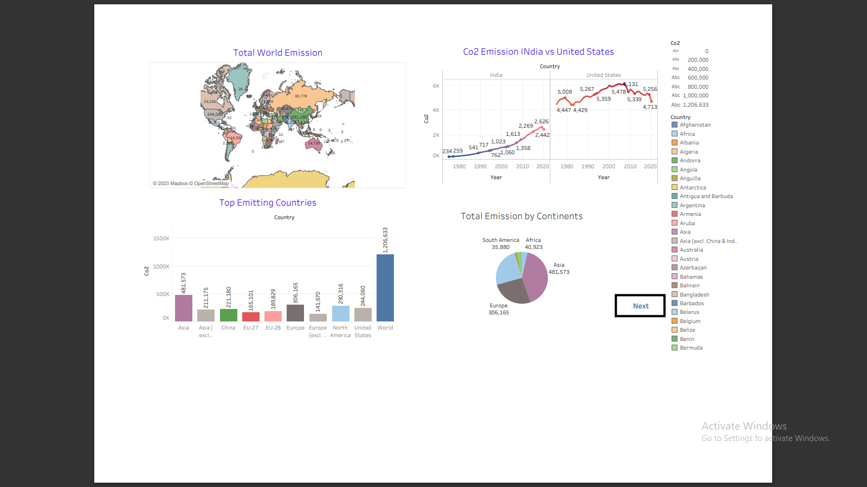

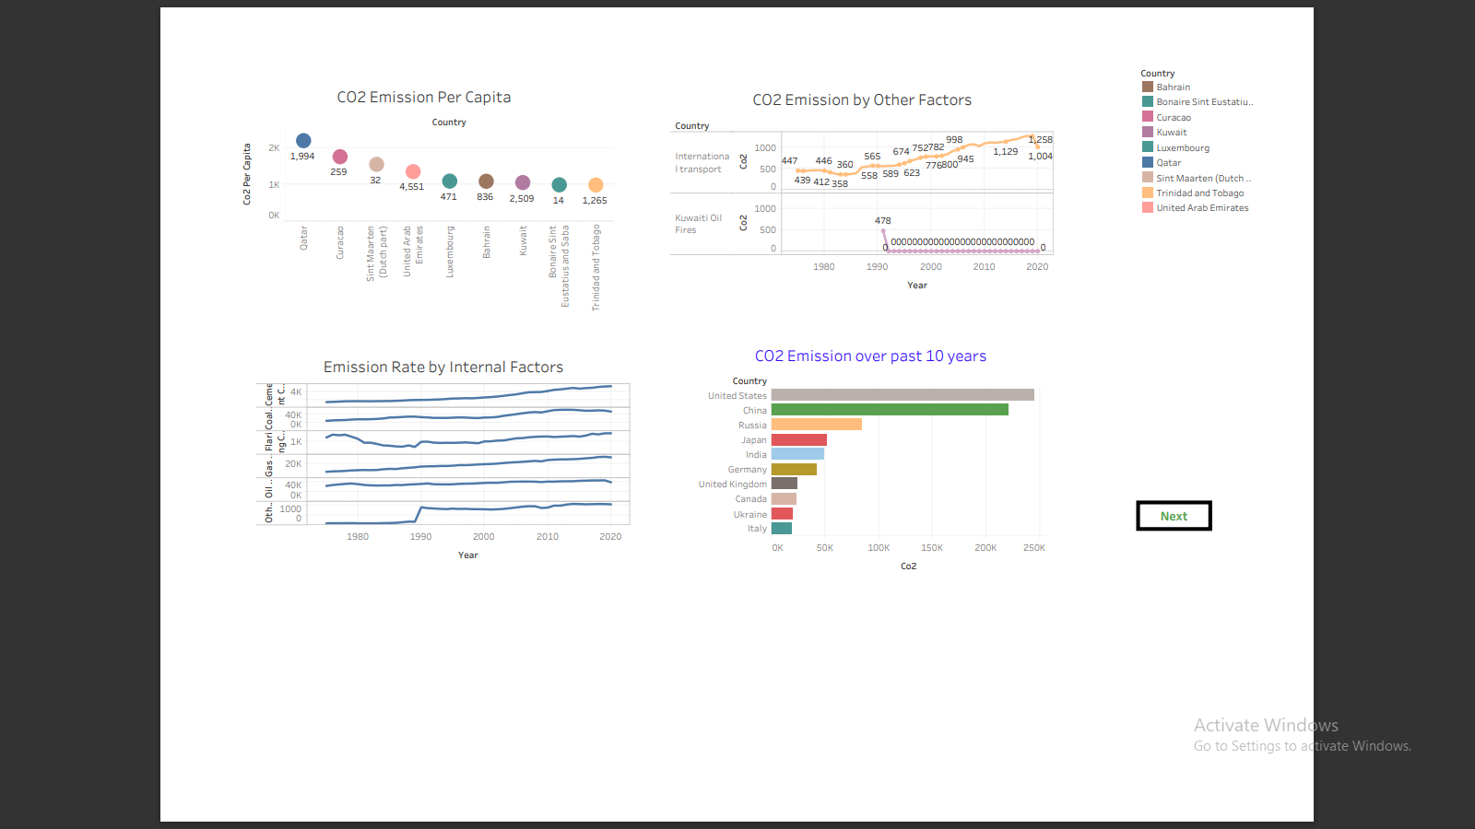

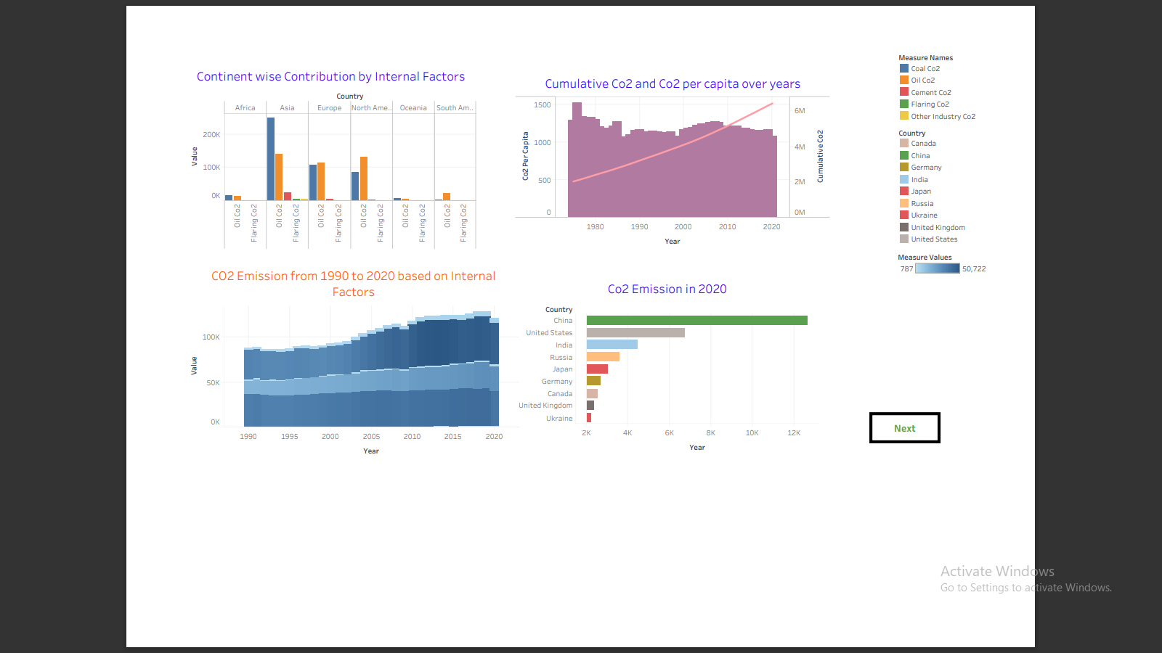

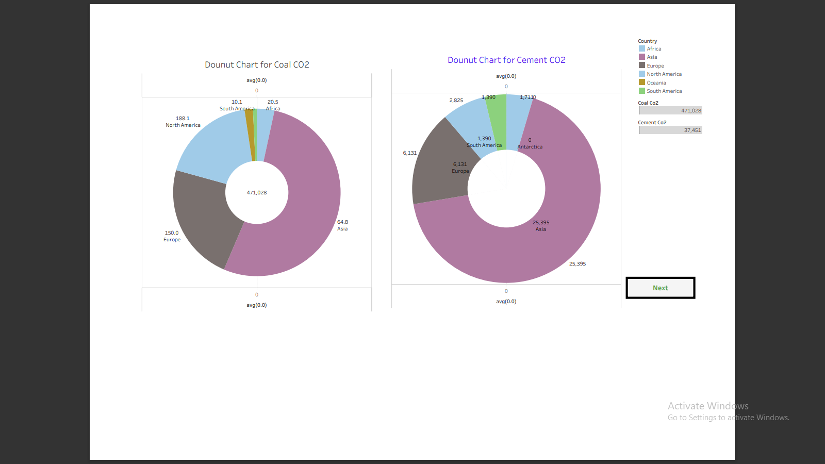

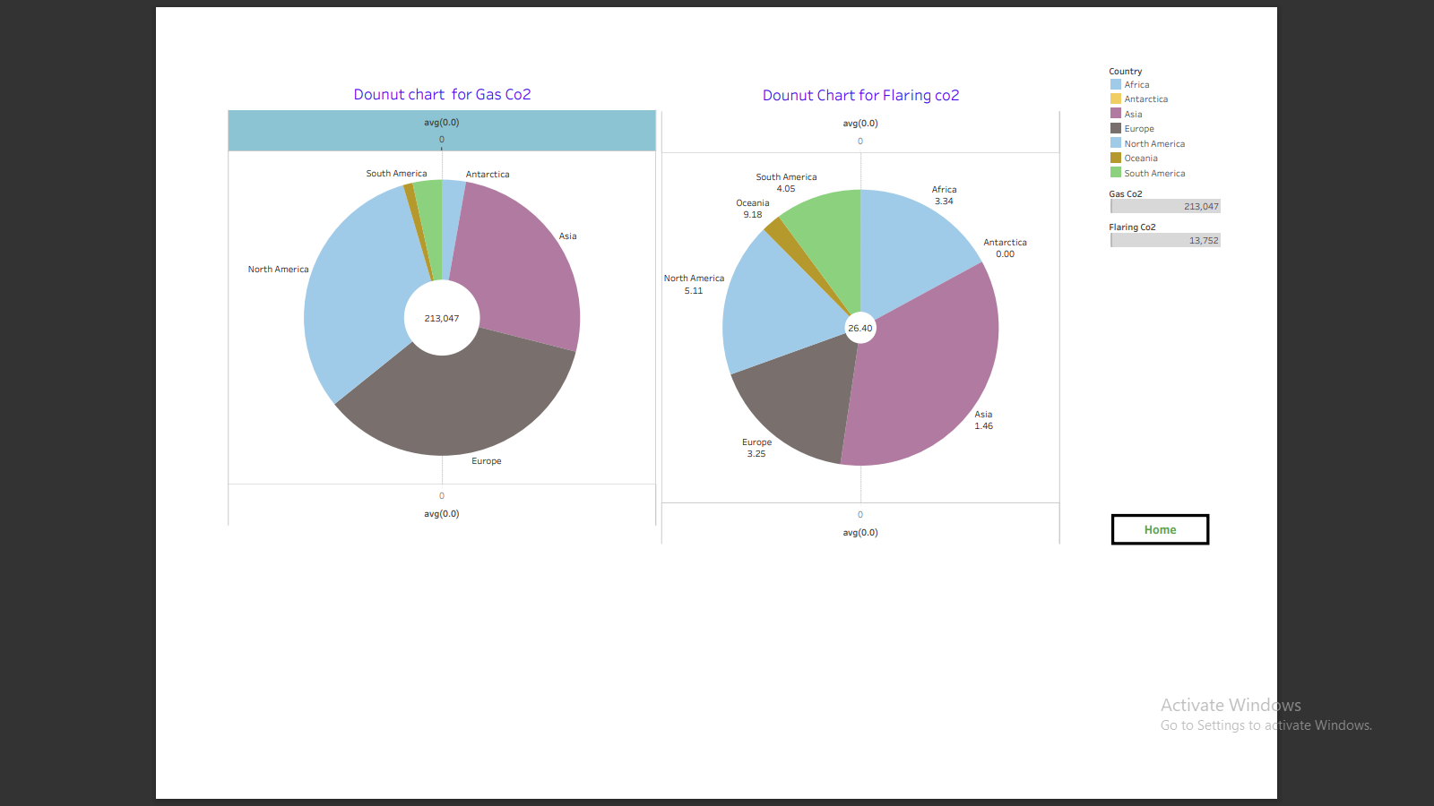

# 

1. TRIALHEAD PROFILE PUBLIC URL

Team leader- <https://trailblazer.me/id/saro823>

Member 1 - <https://trailblazer.me/id/a20016>

Member 2 - <https://traiblazer.me/id/dkumars31>

Member 3 - <https://trailblazer.me/id/gidem1>

Member 4 - <https://trailblazer.me/id/sshyam64>

1. ADVANTAGES $ DISADVANTAGES

Advantages of co2 emission:

1. Green plants grow faster with more CO2
2. Many also become more drought-resistant because higher CO2 levels allow plants to use water more efficiently.
3. More abundant vegetation from increased CO2 is already apparent.
4. Co2 is used as a refreigerant, in fire extiunguishers, fir inflating life rafts and life jackets, blasting coal, foaming rubber and plastics, promoting the growth of plants in greenhouse, immobilizing animals before slaughter, and in carbonated beverages.
5. CO2 emission helps to trap heat in our atmosphere.
6. Without Co2, our planet would be inhospitably cold.
7. However, an increase in VO2 concentrations in our atmosphere is causing averageglobal temperatures to rise, disrupting other aspects of Earth’s climate.
8. Carbon Dioxide is essential for internal respiration in a human body.
9. Carbon Dioxide is a guardian of the pH of the blood, which is essential for survival.
10. Carbon Dioxide is important in photosynthesis.

# Disadvantages

1. High carbon dioxide levels can cause poor air quality and can even extinguish pilot lights on gas-powered appliances.
2. Storage locations can leak co2, as they are often sited near fossil fuel reservoirs.
3. There, oil and gas wellbores provide a pathway for co2 to escape to the surface.
4. MEA is volatile and prone to oxidative degradation and thermal degradation, leading to a large amount of solvent loss.
5. Carbon Dioxide in the atmosphere warms the planet, causing climate change.
6. Human activities have raised the atmospheres carbon dioxide content by 50% in less than 200 years.
7. Exposure to CO2 can produce a variety of health effects.
8. The increasing of CO2 enhancing the unwanted changes in ocean.
9. CO2 may be ineffective at extinguishing class A fires because they may not be able to displace enough oxygen to successfully put the fire out.
10. Alkali metal-Co2 batteries, which combine Co2 recycling with energy conversion and energy crisis and global warming.
11. At even higher levels of CO2 can cause asphyxiation (40000ppm).
12. Application :
13. It is used in Marine Compressors.
14. It is used in Medical gas equipment.
15. Mobility compressors.
16. Oil- free air and nitrogen boosters.
17. Oil-free air blowers.
18. Used air compressors.
19. Conclusion

This preview shows that the Cause of carbon dioxide emissions in world wide. There will a rise in the sea levels around the world, there will be dramatic climate changes, and agriculture will suffer from the fluxes of the weather.

1. Future Scope

CO2 derived chemicals

The carbon in CO2 can be used as an alternative to fossil fuels in the production of chemicals, including plastics, fibres and synthetic rubber. As with CO2 derived fuels, converting CO2 to methanol and methane is the most technologically mature pathway.